Collinear Line Segments

Definition
# Source: AI Source: Provided by: [Data Path: Persons Table -> ID Column: 1, Name_En Column: Motasem Essam] -> From: [ChatGPT] on [7/25/2026]
Collinear Line Segments are two or more line segments whose points all lie on the same straight line.
For two line segments $\overset{‾}{AB}$and $\overset{‾}{CD}$, they are collinear if there exists a single line $l$such that:
$$\boxed{A,B,C,D∈l}$$
In simpler terms, the segments can be placed on the same straight line, even if they are separated, touching, or overlapping.
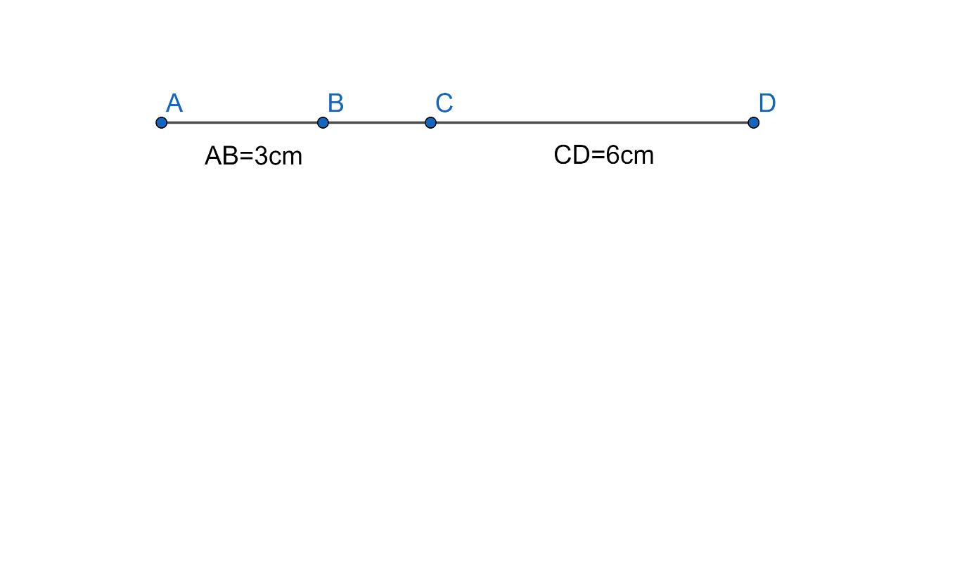
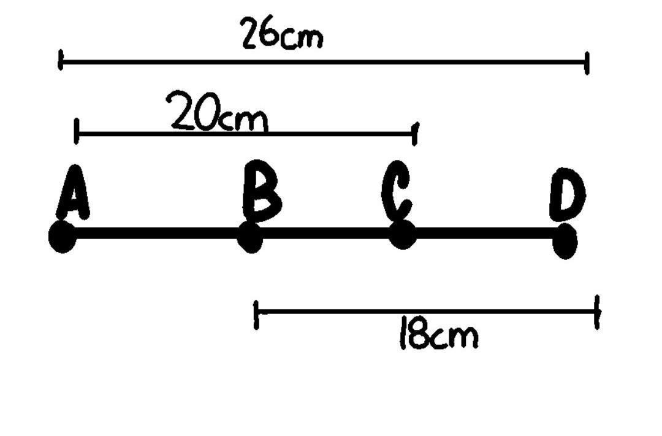
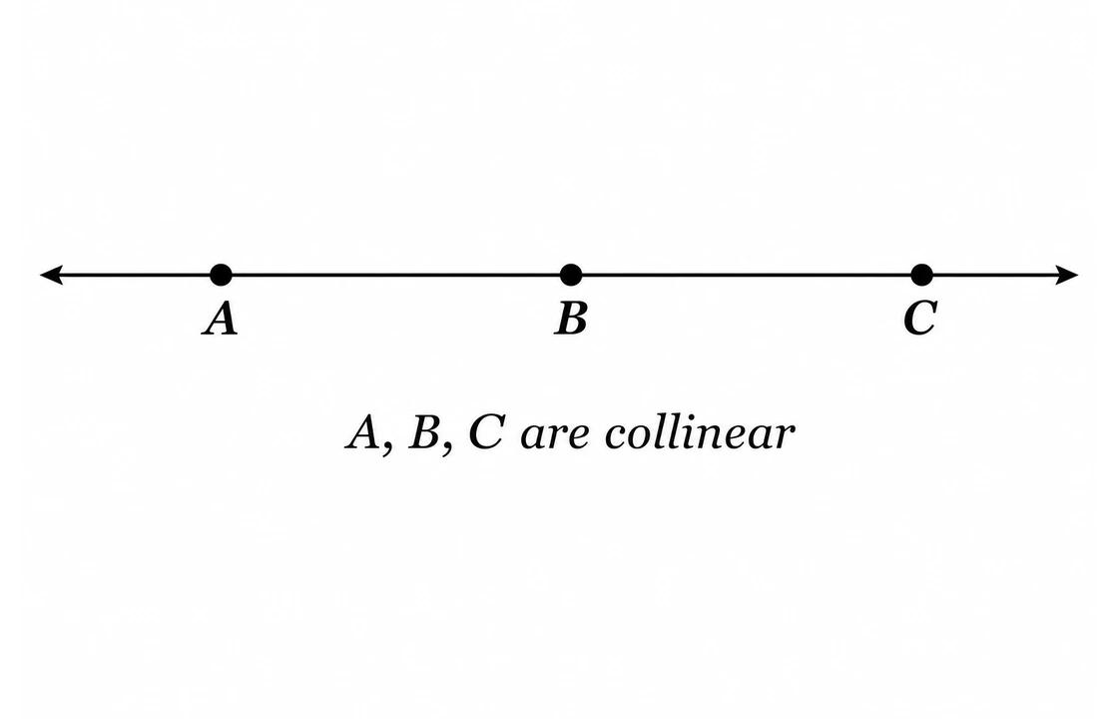
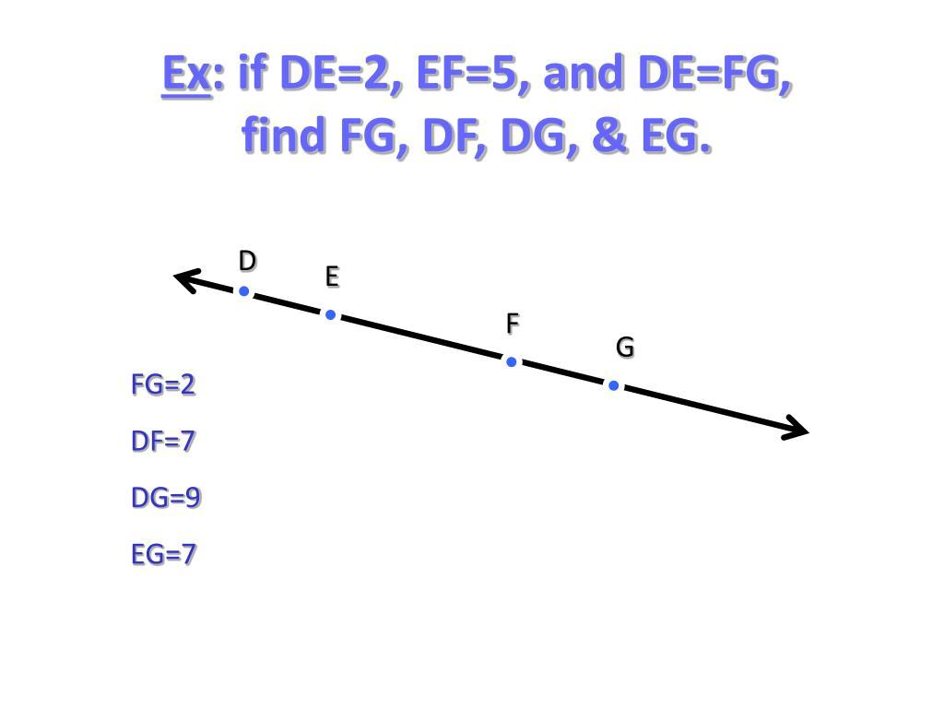

Purpose
# Source: AI Source: Provided by: [Data Path: Persons Table -> ID Column: 1, Name_En Column: Motasem Essam] -> From: [ChatGPT] on [7/25/2026]
Collinear line segments are useful for:
- Studying relationships between line segments on the same line.
- Analyzing gaps and separation.
- Determining whether segments overlap or touch.
- Combining adjacent segments into a longer segment.
- Studying segment lengths and positions on a number line.

Fundamental Concept
# Source: AI Source: Provided by: [Data Path: Persons Table -> ID Column: 1, Name_En Column: Motasem Essam] -> From: [ChatGPT] on [7/25/2026]
Consider:
A────────B C────────D
All four endpoints lie on the same straight line:
$$A,B,C,D∈l$$
Therefore:
$$\boxed{\overset{‾}{AB}\text{ and }\overset{‾}{CD}\text{ are collinear}}$$
The segments do not need to touch each other to be collinear.

Relationships Between Collinear Line Segments
# Source: AI Source: Provided by: [Data Path: Persons Table -> ID Column: 1, Name_En Column: Motasem Essam] -> From: [ChatGPT] on [7/25/2026]
Collinear segments can have several different positional relationships.

1. Separated Collinear Segments
# Source: AI Source: Provided by: [Data Path: Persons Table -> ID Column: 1, Name_En Column: Motasem Essam] -> From: [ChatGPT] on [7/25/2026]
The segments lie on the same line but have a positive gap between them.
A──────B C──────D
← Gap →
If $B<C$, the gap is:
$$\boxed{g=BC}$$
This is a Linear Gap.

2. Touching Collinear Segments
# Source: AI Source: Provided by: [Data Path: Persons Table -> ID Column: 1, Name_En Column: Motasem Essam] -> From: [ChatGPT] on [7/25/2026]
The segments meet at exactly one endpoint.
A──────B──────D
C
If:
$$B=C$$
then:
$$\boxed{g=0}$$
The segments are collinear and in contact.

3. Overlapping Collinear Segments
# Source: AI Source: Provided by: [Data Path: Persons Table -> ID Column: 1, Name_En Column: Motasem Essam] -> From: [ChatGPT] on [7/25/2026]
The segments lie on the same line and share part of their lengths.
A──────────D
C──────────B
The common portion is:
$$\boxed{\overset{‾}{CD}}$$
assuming the endpoint order is:
$$A<C<D<B$$

4. Partially Overlapping Segments
# Source: AI Source: Provided by: [Data Path: Persons Table -> ID Column: 1, Name_En Column: Motasem Essam] -> From: [ChatGPT] on [7/25/2026]
Only part of each segment is common.
A────────────B
C────────────D
The overlapping portion is:
$$\boxed{\overset{‾}{CB}}$$
when:
$$A<C<B<D$$

5. Coincident Collinear Segments
# Source: AI Source: Provided by: [Data Path: Persons Table -> ID Column: 1, Name_En Column: Motasem Essam] -> From: [ChatGPT] on [7/25/2026]
Two segments occupy exactly the same set of points.
A────────────B
C────────────D
If:
$$\boxed{\overset{‾}{AB}=\overset{‾}{CD}}$$
the segments are coincident.

Mathematical Representation
# Source: AI Source: Provided by: [Data Path: Persons Table -> ID Column: 1, Name_En Column: Motasem Essam] -> From: [ChatGPT] on [7/25/2026]
For two segments lying on the $x$-axis:
$$\overset{‾}{AB}=\left[a , b\right]$$
and:
$$\overset{‾}{CD}=\left[c , d\right]$$
with:
$$a≤b, c≤d$$
their relationship can be determined by comparing the intervals.
Separated
$$\boxed{b<c \text{or} d<a}$$
Touching
$$\boxed{b=c \text{or} d=a}$$
Overlapping
$$\boxed{max⁡\left(a , c\right)<min⁡\left(b , d\right)}$$
Coincident
$$\boxed{a=c \text{and} b=d}$$

Conditions for Collinearity
# Source: AI Source: Provided by: [Data Path: Persons Table -> ID Column: 1, Name_En Column: Motasem Essam] -> From: [ChatGPT] on [7/25/2026]
For points in a plane:
$$A\left(x_{1} , y_{1}\right), B\left(x_{2} , y_{2}\right), C\left(x_{3} , y_{3}\right)$$
the points are collinear if:
$$\boxed{\left(x_{2}-x_{1}\right)\left(y_{3}-y_{1}\right)-\left(y_{2}-y_{1}\right)\left(x_{3}-x_{1}\right)=0}$$
For two line segments, all their endpoints must lie on the same line.
Example
Consider:
$$A\left(1 , 2\right), B\left(5 , 2\right)$$
and:
$$C\left(8 , 2\right), D\left(12 , 2\right)$$
All four points have:
$$y=2$$
Therefore, they lie on the same horizontal line:
$$\boxed{y=2}$$
Hence:
$$\boxed{\overset{‾}{AB}\text{ and }\overset{‾}{CD}\text{ are collinear}}$$
They are also separated because:
$$5<8$$
and the gap is:
$$g=8-5=3$$

Collinear vs. Parallel Line Segments
# Source: AI Source: Provided by: [Data Path: Persons Table -> ID Column: 1, Name_En Column: Motasem Essam] -> From: [ChatGPT] on [7/25/2026]
These concepts should not be confused.
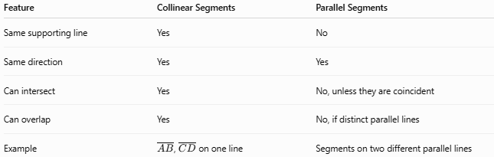
Feature | Collinear Segments | Parallel Segments
Same supporting line | Yes | No
Same direction | Yes | Yes
Can intersect | Yes | No, unless they are coincident
Can overlap | Yes | No, if distinct parallel lines
Example | $\overset{‾}{AB}$, $\overset{‾}{CD}$on one line | Segments on two different parallel lines
For example:
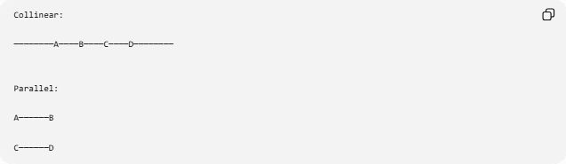
Collinear:

────────A────B────C────D────────

Parallel:

A──────B

C──────D
The second pair has the same direction but lies on different lines.

Collinear Segments and Gaps
# Source: AI Source: Provided by: [Data Path: Persons Table -> ID Column: 1, Name_En Column: Motasem Essam] -> From: [ChatGPT] on [7/25/2026]
This concept is particularly relevant to your Gap classification.
For two separated collinear segments:
A──────B C──────D
← g →
the gap is:
$$\boxed{g=BC}$$
Thus:
$$\boxed{\text{Separated Collinear Segments}→\text{Linear Gap}}$$
If the segments touch:
$$g=0$$
and the relationship becomes Contact.
If they overlap:
$$\text{Intersection/Overlap}$$
occurs instead.

Key Points
# Source: AI Source: Provided by: [Data Path: Persons Table -> ID Column: 1, Name_En Column: Motasem Essam] -> From: [ChatGPT] on [7/25/2026]
- Collinear line segments lie on the same straight line.
- They may be:
  - separated,
  - touching,
  - overlapping,
  - or coincident.
- They do not have to touch to be collinear.
- Separated collinear segments have a linear gap.
- Touching collinear segments have a gap of zero.
- Overlapping collinear segments share a portion of their length.
- Collinear segments are different from parallel segments because collinear segments share the same supporting line.

Conclusion
# Source: AI Source: Provided by: [Data Path: Persons Table -> ID Column: 1, Name_En Column: Motasem Essam] -> From: [ChatGPT] on [7/25/2026]
Collinear Line Segments are line segments whose points lie on one common straight line. Their positional relationship can then be classified as separated, touching, overlapping, or coincident. This makes collinearity particularly useful when studying linear gaps, contact, overlap, and containment of line segments.

